ME-Meopotamia-Seal-Hunter, Chariot, Lion

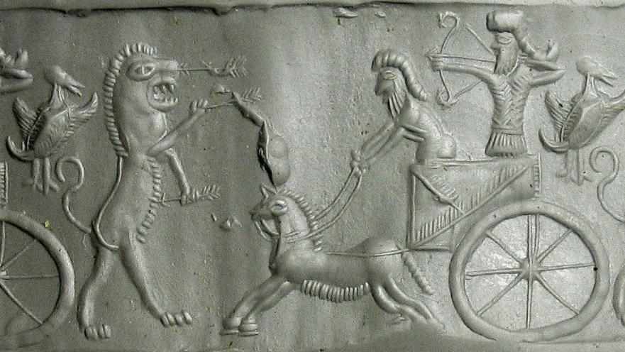

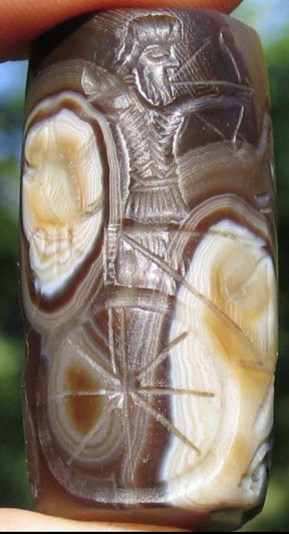

Formal Label:

Accession Number:

Date or Time Horizon: 3000 BCE

Geographical Area: Mesopotamia

Cultural Affiliation:

Medium: Agate

Dimensions: 44 mm

Weight:

Provenance: